**VISVESVARAYA TECHNOLOGICAL UNIVERSITY**

**“JnanaSangama”, Belgaum -590014, Karnataka.**



**LAB REPORT**

**on**

**Object Oriented Java Programming (23CS3PCOOJ)**

***Submitted by***

**Aayush Soni (1BM23CS007)**

***in partial fulfillment for the award of the degree of***

**BACHELOR OF ENGINEERING**

***in***

**COMPUTER SCIENCE AND ENGINEERING**



**B.M.S. COLLEGE OF ENGINEERING**

**(Autonomous Institution under VTU)**

**BENGALURU-560019**

**Sep-2024 to Jan-2025**

**B.M.S. College of Engineering,**

**Bull Temple Road, Bangalore 560019**

(Affiliated To Visvesvaraya Technological University, Belgaum)

**Department of Computer Science and Engineering**



**CERTIFICATE**

This is to certify that the Lab work entitled “Object Oriented Java Programming (23CS3PCOOJ)” carried out by Aayush Soni **(1BM23CS007),** who is bonafide student of **B.M.S. College of Engineering.** It is in partial fulfillment for the award of **Bachelor of Engineering in Computer Science and Engineering** of the Visvesvaraya Technological University, Belgaum. The Lab report has been approved as it satisfies the academic requirements in respect of an Object Oriented Java Programming (23CS3PCOOJ) work prescribed for the said degree.

| Lab faculty Incharge: Geetha N  Assistant Professor  Department of CSE, BMSCE | Dr. Jyothi S Nayak  Professor & HOD  Department of CSE, BMSCE |
| --- | --- |

**Index**

| **Sl.**  **No.** | **Date** | **Experiment Title** | **Page No.** |
| --- | --- | --- | --- |
| 1 |  |  |  |
| 2 |  |  |  |
| 3 |  |  |  |
| 4 |  |  |  |
| 5 |  |  |  |
| 6 |  |  |  |
| 7 |  |  |  |
| 8 |  |  |  |
| 9 |  |  |  |
| 10 |  |  |  |

Github Link:

https://github.com/sonistudy/JAVA-LAB

**Program 1**

Implement Quadratic Equation

Code:

import java.util.Scanner;

public class Quadra {

public static void main(String[] args) {

Scanner scanner = new Scanner(System.in);

System.out.print("Enter coefficient a: ");

double a = scanner.nextDouble();

System.out.print("Enter coefficient b: ");

double b = scanner.nextDouble();

System.out.print("Enter coefficient c: ");

double c = scanner.nextDouble();

double discriminant = b * b - 4 * a * c;

if (discriminant > 0) {

double root1 = (-b + Math.sqrt(discriminant)) / (2 * a);

double root2 = (-b - Math.sqrt(discriminant)) / (2 * a);

System.out.printf("The solutions are: %.2f and %.2f%n", root1, root2);

} else if (discriminant == 0) {

double root = -b / (2 * a);

System.out.printf("There is one solution: %.2f%n", root);

} else {

System.out.println("There are no real solutions.");

}

scanner.close();

}

}

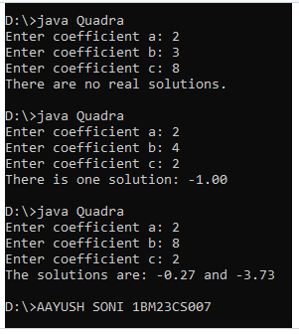

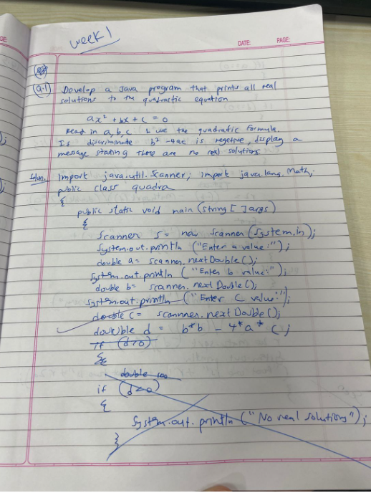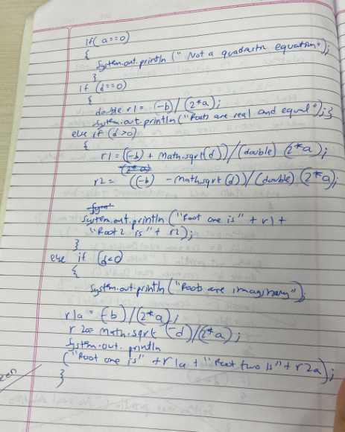

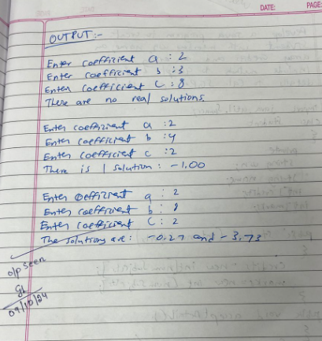

**Program 2**

Implement Class and Functions

Code:

import java.util.Scanner;

class Student {

private String usn;

private String name;

private int[] credits;

private int[] marks;

public Student(int numSubjects) {

credits = new int[numSubjects];

marks = new int[numSubjects];

}

public void acceptDetails() {

Scanner scanner = new Scanner(System.in);

System.out.print("Enter USN: ");

usn = scanner.nextLine();

System.out.print("Enter Name: ");

name = scanner.nextLine();

for (int i = 0; i < credits.length; i++) {

System.out.print("Enter credits for subject " + (i + 1) + ": ");

credits[i] = scanner.nextInt();

System.out.print("Enter marks for subject " + (i + 1) + ": ");

marks[i] = scanner.nextInt();

}

}

public void displayDetails() {

System.out.println("\nStudent Details:");

System.out.println("USN: " + usn);

System.out.println("Name: " + name);

System.out.println("Credits and Marks:");

for (int i = 0; i < credits.length; i++) {

System.out.println("Subject " + (i + 1) + ": Credits = " + credits[i] + ", Marks = " + marks[i]);

}

}

public double calculateSGPA() {

double totalPoints = 0;

int totalCredits = 0;

for (int i = 0; i < credits.length; i++) {

totalPoints += (marks[i] * credits[i]);

totalCredits += credits[i];

}

if (totalCredits == 0) {

return 0;

} else {

return totalPoints / totalCredits;

}

}

public static void main(String[] args) {

Scanner scanner = new Scanner(System.in);

System.out.print("Enter number of subjects: ");

int numSubjects = scanner.nextInt();

Student student = new Student(numSubjects);

student.acceptDetails();

student.displayDetails();

double sgpa = student.calculateSGPA();

System.out.println("SGPA: " + sgpa);

}

}

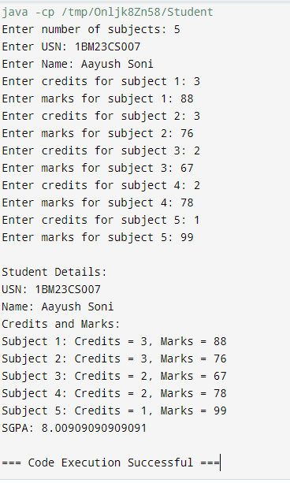

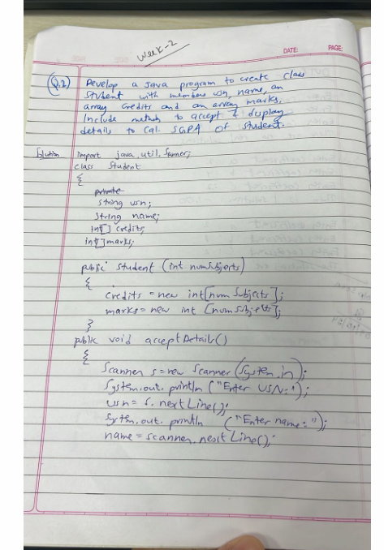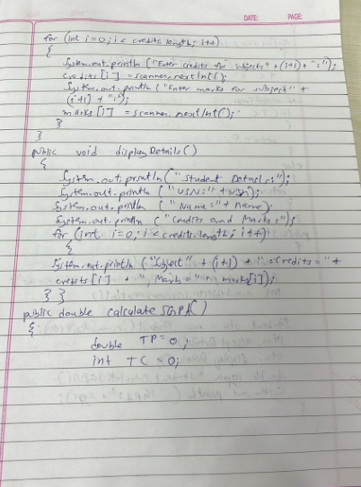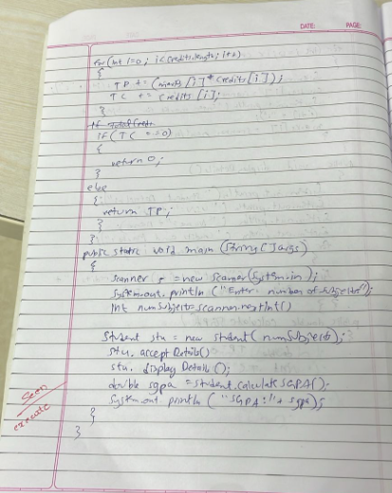

**Program 3**

Implement Class and Functions and constructors

Code:

import java.util.Scanner;

class Book {

private String name;

private String author;

private double price;

private int numPages;

// Constructor

public Book(String name, String author, double price, int numPages) {

this.name = name;

this.author = author;

this.price = price;

this.numPages = numPages;

}

// Setters

public void setName(String name) {

this.name = name;

}

public void setAuthor(String author) {

this.author = author;

}

public void setPrice(double price) {

this.price = price;

}

public void setNumPages(int numPages) {

this.numPages = numPages;

}

// Getters

public String getName() {

return name;

}

public String getAuthor() {

return author;

}

public double getPrice() {

return price;

}

public int getNumPages() {

return numPages;

}

// toString method

@Override

public String toString() {

return "Book Name: " + name + ", Author: " + author + ", Price: " + price + ", Number of Pages: " + numPages;

}

}

public class BookMain {

public static void main(String[] args) {

Scanner scanner = new Scanner(System.in);

System.out.print("Enter the number of books: ");

int n = scanner.nextInt();

scanner.nextLine(); // Consume the newline

Book[] books = new Book[n];

for (int i = 0; i < n; i++) {

System.out.println("Enter details for book " + (i + 1) + ":");

System.out.print("Name: ");

String name = scanner.nextLine();

System.out.print("Author: ");

String author = scanner.nextLine();

System.out.print("Price: ");

double price = scanner.nextDouble();

System.out.print("Number of Pages: ");

int numPages = scanner.nextInt();

scanner.nextLine(); // Consume the newline

books[i] = new Book(name, author, price, numPages);

}

System.out.println("\nBook Details:");

for (Book book : books) {

System.out.println(book);

}

scanner.close();

}

}

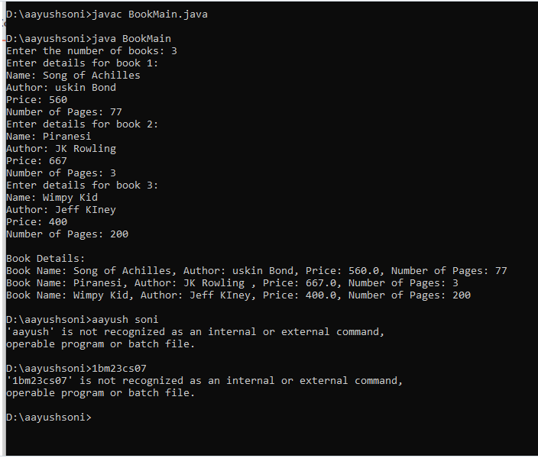

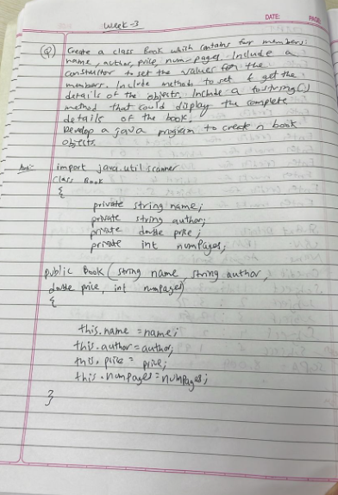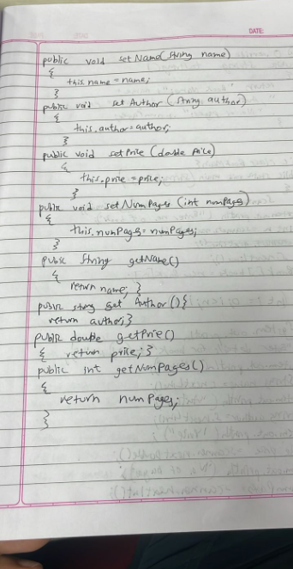

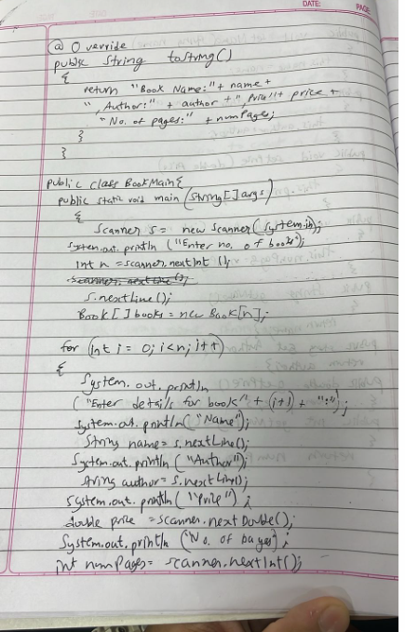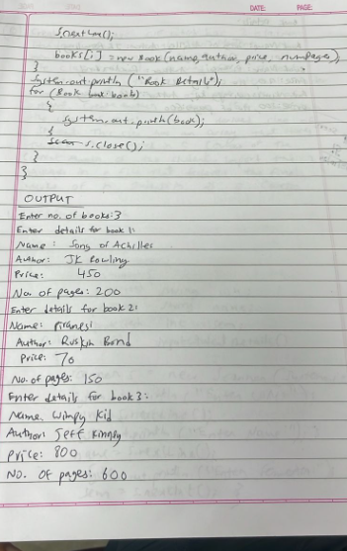

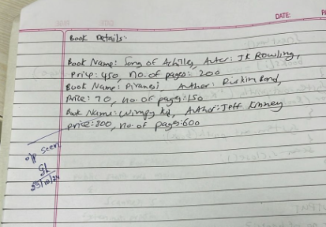

**Program 6**

Implement Packages

Code:

import SEE.Externals;

import java.util.Scanner;

class Main {

public static void main(String[] args) {

Scanner s = new Scanner(System.in);

System.out.print("Enter number of students: ");

int n = s.nextInt();

Externals[] students = new Externals[n];

for (int i = 0; i < n; i++) {

System.out.println("\nEnter details for student " + (i + 1) + ":");

students[i] = new Externals();

students[i].inputStudentDetails();

students[i].inputCIEmarks();

students[i].inputSEEmarks();

students[i].calculateFinalMarks();

}

System.out.println("\nFinal Marks of Students:");

for (int i = 0; i < n; i++) {

System.out.println("\nStudent " + (i + 1) + ":");

students[i].displayFinalMarks();

}

}

}

package SEE;

import CIE.Internals;

import java.util.Scanner;

public class Externals extends Internals {

private int[] seeMarks = new int[5];

private int[] finalMarks = new int[5];

public void inputSEEmarks() {

Scanner s = new Scanner(System.in);

System.out.println("Enter SEE Marks for 5 subjects:");

for (int i = 0; i < 5; i++) {

System.out.print("Subject " + (i + 1) + ": ");

seeMarks[i] = s.nextInt();

}

}

public void calculateFinalMarks() {

for (int i = 0; i < 5; i++) {

finalMarks[i] = internalMarks[i] + seeMarks[i];

}

}

public void displayFinalMarks() {

displayStudentDetails();

System.out.println("Final Marks for 5 subjects:");

for (int i = 0; i < 5; i++) {

System.out.println("Subject " + (i + 1) + ": " + finalMarks[i]);

}

}

}

package CIE;

import java.util.Scanner;

public class Internals extends Student {

protected int[] internalMarks = new int[5];

public void inputCIEmarks() {

Scanner s = new Scanner(System.in);

System.out.println("Enter Internal Marks for 5 subjects:");

for (int i = 0; i < 5; i++) {

System.out.print("Subject " + (i + 1) + ": ");

internalMarks[i] = s.nextInt();

}

}

}

package CIE;

import java.util.Scanner;

public class Student {

protected String usn;

protected String name;

protected int sem;

public void inputStudentDetails() {

Scanner s = new Scanner(System.in);

System.out.print("Enter USN: ");

usn = s.nextLine();

System.out.print("Enter Name: ");

name = s.nextLine();

System.out.print("Enter Semester: ");

sem = s.nextInt();

}

public void displayStudentDetails() {

System.out.println("USN: " + usn);

System.out.println("Name: " + name);

System.out.println("Semester: " + sem);

}

}

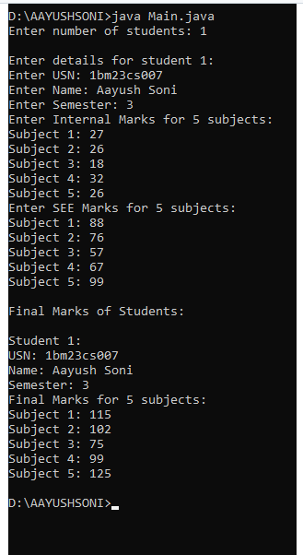

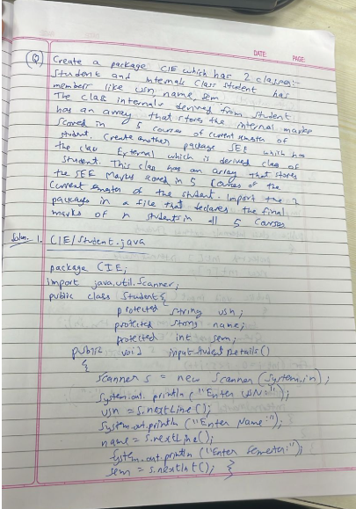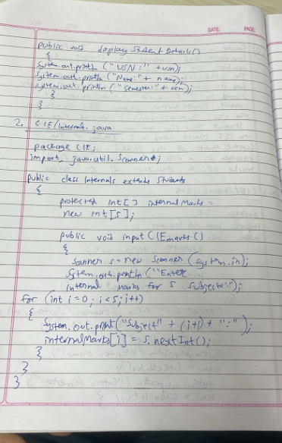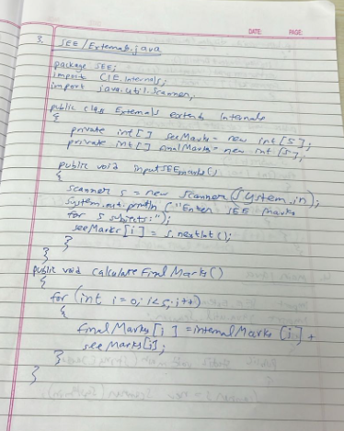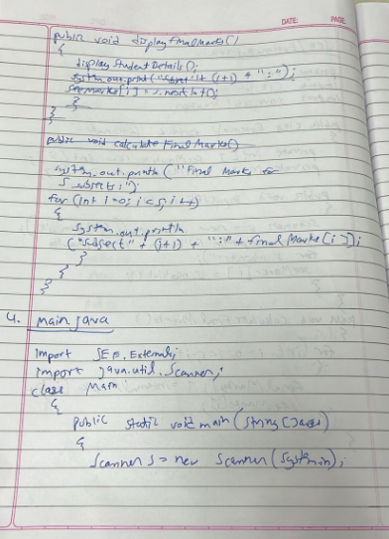

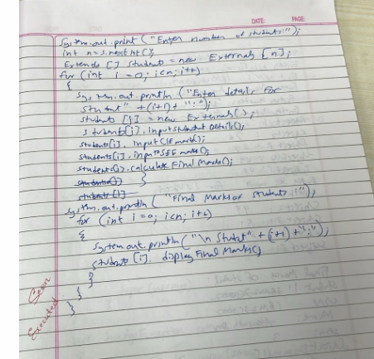

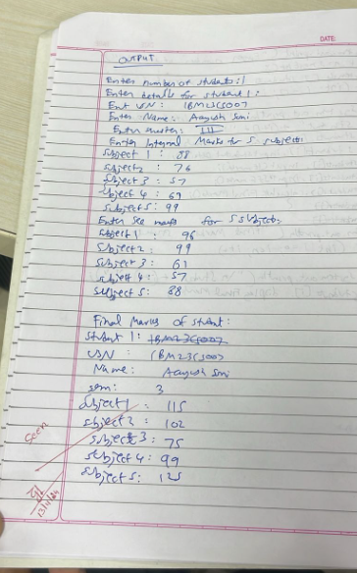

**Program 7**

Implement Handling Exceptions

Code:

class Age extends Exception{

public Age(String message){

super(message);

}

}

class father{

int age;

public father(int age) throws Age {

if (age < 0) {

throw new Age("Age cannot be less than zero");

}

this.age = age;

System.out.println("Father's age is= " + this.age);

}

}

class son extends father{

int sonage;

public son(int fatherage, int sonage) throws Age {

super(fatherage);

if (sonage < 0) {

throw new Age("Son's age cannot be less than zero");

}

if (sonage >= fatherage) {

throw new Age("Son's age cannot be more than or equal to Father's age");

}

this.sonage = sonage;

System.out.println("Son's age is= " + this.sonage);

}

}

public class InheritanceTree{

public static void main(String[] args) {

try{

System.out.println("CASE 1: Valid case");

son son1 = new son(60, 20);

System.out.println("\nCASE 2: Son's age is more than or equal to Father's age");

son son2 = new son(20, 30);

} catch(Age a){

System.out.println("Exception: " + a.getMessage());

}

try{

System.out.println("\nCASE 3: Father's age is less than zero");

father father1 = new father(-20);

}

catch (Age a){

System.out.println("Exception: " + a.getMessage());

}

}

}

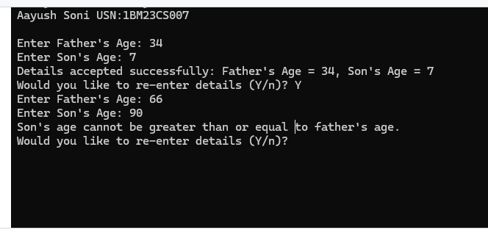

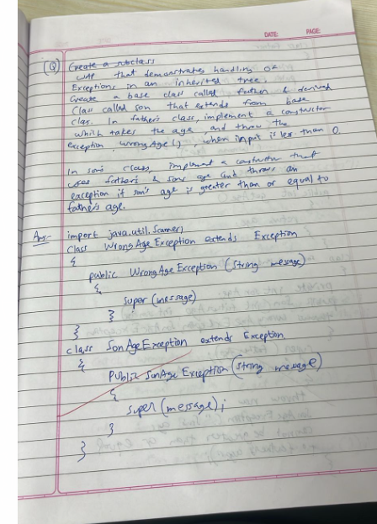S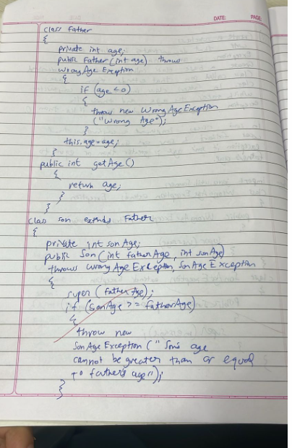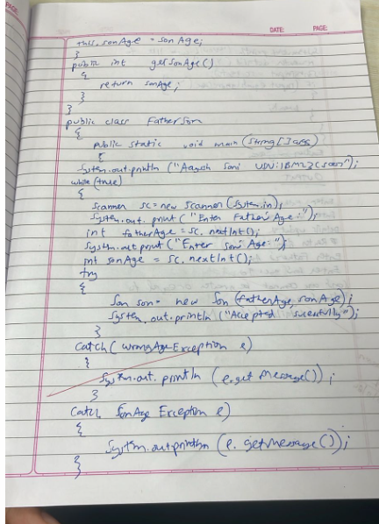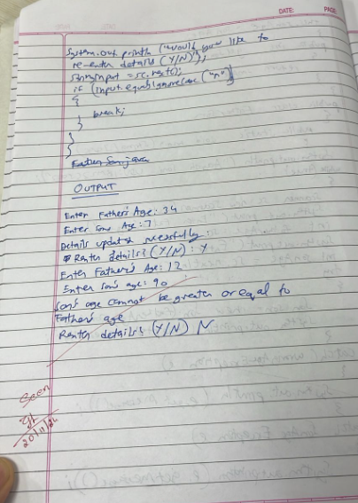

**Program 5**

Bank Program

Code:import java.util.*;

abstract class Account {

String Cust_name ,Acc_num;

double balance;

Account(String Cust_name,String Acc_num, double inti_bala){

this.Cust_name=Cust_name;

this.Acc_num=Acc_num;

this.balance=inti_bala;

}

abstract void deposit(double amt);

abstract void displayBalance();

abstract void withdraw(double amt);

}

class Sav_Acct extends Account{

double intrestRate;

Sav_Acct(String Cust_name,String Acc_num, double inti_bala){

super(Cust_name,Acc_num,inti_bala);

this.intrestRate=intrestRate;

}

void deposit(double amt){

balance+=amt;

}

void displayBalance(){

System.out.println("Saving Balance:"+balance);

}

void withdraw(double amt){

if(amt<=balance){

balance-=amt;

}

}

void computeAndDepositeIntrest(){

balance+=balance*intrestRate/100;

}

}

class Cur_Acct extends Account{

static final double MIN_BALANCE=1000, SEVICE_CHARGE=50;

Cur_Acct(String Cust_name,String Acc_num, double inti_bala){

super(Cust_name,Acc_num,inti_bala);

}

void deposit(double amt){

balance+=amt;

}

void displayBalance(){

System.out.println("Saving Balance:"+balance);

}

void withdraw(double amt){

if(amt<=balance){

balance-=amt;

if(balance<MIN_BALANCE){

balance-=SEVICE_CHARGE;

}

}

}

}

class Bank{

public static void main(String[] args){

Scanner scn=new Scanner(System.in);

System.out.println("Enter account type(savings/current):");

String type=scn.nextLine();

System.out.println("Enter account name:");

String name=scn.nextLine();

System.out.println("Enter account number:");

String number=scn.nextLine();

Account account;

if(type.equals("Savings")){

System.out.println("Initial balance and interest rate:");

account=new Sav_Acct(name,number,scn.nextDouble());

}

else{

System.out.println("Intial balance :");

account =new Cur_Acct(name,number,scn.nextDouble());

}

while(true){

System.out.println("1.Deposit 2.Display Balance 3.Withdraw 4.Interest 5.Exit");

int choice=scn.nextInt();

switch(choice){

case 1:account.deposit(scn.nextDouble());

break;

case 2: account.displayBalance();

break;

case 3: account.withdraw(scn.nextDouble());

break;

case 4: if(account instanceof Sav_Acct){

((Sav_Acct)account).computeAndDepositeIntrest();

}

break;

case 5 : return;

}

}

}

}

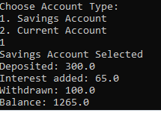

**Program 10**

Implementation of Threads

Code:

class A {

synchronized void foo(B b) {

String name = Thread.currentThread().getName();

System.out.println(name + " entered A.foo");

try {

Thread.sleep(1000);

} catch (InterruptedException e) {

System.out.println("A Interrupted");

}

System.out.println(name + " trying to call B.last()");

b.last();

}

void last() {

System.out.println("Inside A.last");

}

}

class B {

synchronized void bar(A a) {

String name = Thread.currentThread().getName();

System.out.println(name + " entered B.bar");

try {

Thread.sleep(1000);

} catch (InterruptedException e) {

System.out.println("B Interrupted");

}

System.out.println(name + " trying to call A.last()");

a.last();

}

void last() {

System.out.println("Inside B.last");

}

}

class Deadlock implements Runnable {

A a = new A();

B b = new B();

Deadlock() {

Thread.currentThread().setName("MainThread");

Thread t = new Thread(this, "RacingThread");

t.start();

a.foo(b); // Main thread calls foo on object A, locking A

System.out.println("Back in main thread");

}

public void run() {

b.bar(a); // Racing thread calls bar on object B, locking B

System.out.println("Back in other thread");

}

public static void main(String args[]) {

System.out.println("1BM23CS007 AAYUSH SONI");

new Deadlock();

}

}

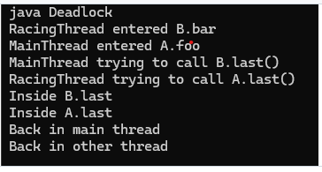

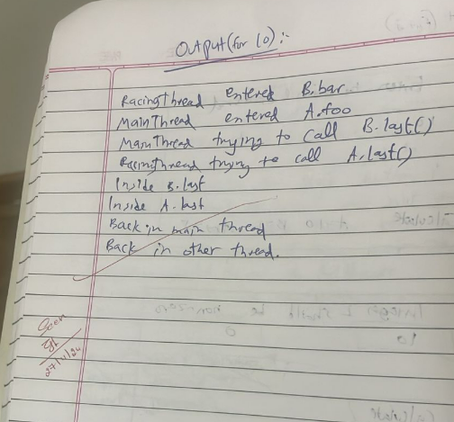

**Program 4**

Shape Program

Code:abstract class Shape {

protected int dimension1; // could represent length, base, or radius

protected int dimension2; // could represent width or height, or could be unused for Circle

// Abstract method to print area

public abstract void printArea();

}

class Rectangle extends Shape {

public Rectangle(int length, int width) {

this.dimension1 = length;

this.dimension2 = width;

}

@Override

public void printArea() {

int area = dimension1 * dimension2;

System.out.println("Area of Rectangle: " + area);

}

}

class Triangle extends Shape {

public Triangle(int base, int height) {

this.dimension1 = base;

this.dimension2 = height;

}

@Override

public void printArea() {

double area = 0.5 * dimension1 * dimension2;

System.out.println("Area of Triangle: " + area);

}

}

class Circle extends Shape {

public Circle(int radius) {

this.dimension1 = radius; // Only one dimension is needed for Circle

}

@Override

public void printArea() {

double area = Math.PI * dimension1 * dimension1;

System.out.println("Area of Circle: " + area);

}

}

public class ShapeTest {

public static void main(String[] args) {

Shape rectangle = new Rectangle(5, 3);

rectangle.printArea();

Shape triangle = new Triangle(4, 6);

triangle.printArea();

Shape circle = new Circle(7);

circle.printArea();

}

}

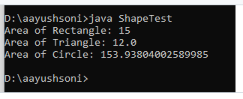

**Program 8**

Display using Threads

Code:

class Collegethread extends Thread{

public void run(){

try{

for(int i=0;i<5;i++){

System.out.println("BMS College of Engineering");

Thread.sleep(10000);

}

}

catch(InterruptedException e){

System.out.println("College Thread interrupted.");

}

}

}

class CSEthread extends Thread{

public void run(){

try{

for (int i = 0; i < 25; i++){

System.out.println("CSE");

Thread.sleep(2000);

}

}

catch (InterruptedException e){

System.out.println("CSE Thread interrupted.");

}

}

}

public class ThreadProgram{

public static void main(String[] args){

Collegethread collegethread=new Collegethread();

CSEthread csethread=new CSEthread();

collegethread.start();

csethread.start();

}

}

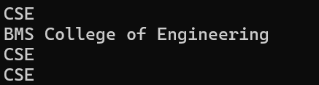

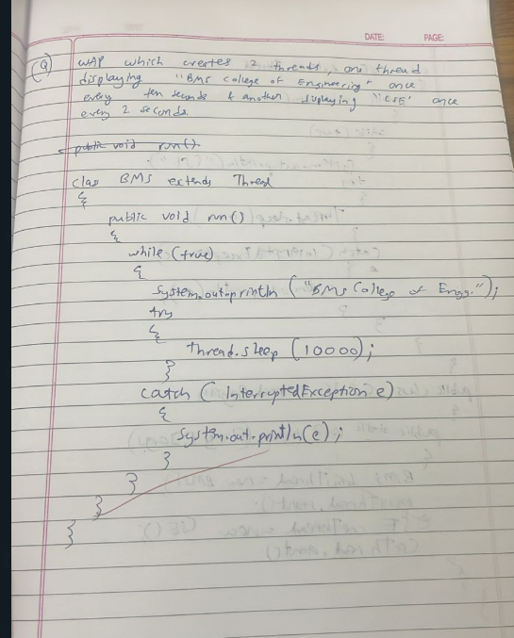

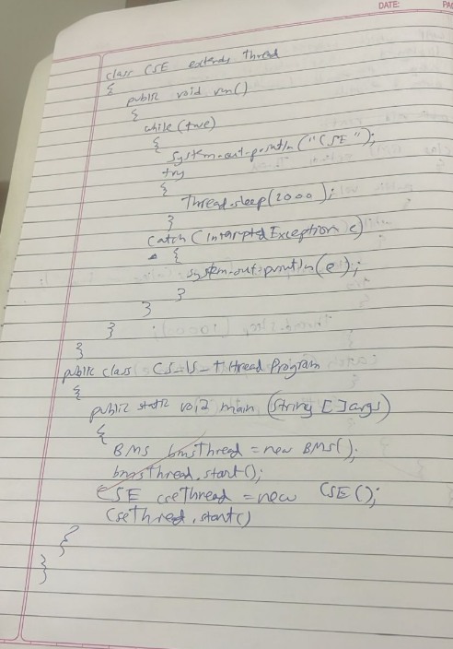

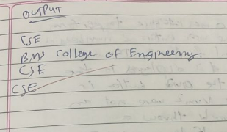

**Program 9**

Dialogue Box input

